Detecting Unusual Activity in Video:

<http://repository.upenn.edu/cgi/viewcontent.cgi?article=1032&context=cis_papers&sei-redir=1&referer=http%3A%2F%2Fscholar.google.com%2Fscholar%3Fhl%3Den%26q%3Dactivity%2Bdetection%2Bvideo%26btnG%3D%26as_sdt%3D1%252C33%26as_sdtp%3D#search=%22activity%20detection%20video%22>

This week I looked into the links sent by Keith:

[http://crcv.ucf.edu/projects/ViewInvariance/](http://crcv.ucf.edu/projects/ViewInvariance/" \t "_blank)  
[http://vision.ucla.edu/~raptis/kinect\_dance.html](http://vision.ucla.edu/~raptis/kinect_dance.html" \t "_blank)  
[http://www.cfar.umd.edu/~vashok/Documents/veeraraghavan\_a.pdf](http://www.cfar.umd.edu/~vashok/Documents/veeraraghavan_a.pdf" \t "_blank)  
[http://dl.acm.org/citation.cfm?id=2490271](http://dl.acm.org/citation.cfm?id=2490271" \t "_blank)  
[http://dl.acm.org/citation.cfm?id=1340252](http://dl.acm.org/citation.cfm?id=1340252" \t "_blank)

survey paper:  
[http://www.redaktion.tu-berlin.de/fileadmin/fg41/download/Team/daniel\_weinland/weinland10b.pdf](http://www.redaktion.tu-berlin.de/fileadmin/fg41/download/Team/daniel_weinland/weinland10b.pdf" \t "_blank)

More ideas for potential topic:

* Projecting on 3D objects
* Projecting on non-flat surfaces, e.g. wall in the RKC

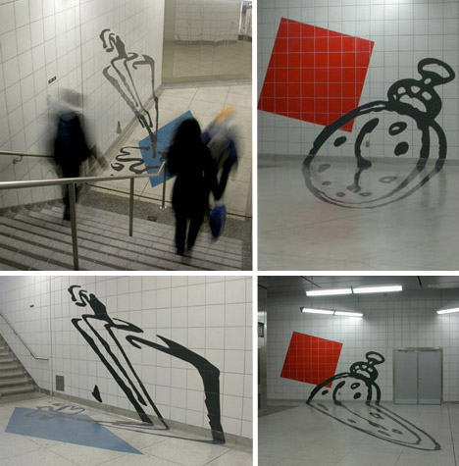

<http://img.weburbanist.com/wp-content/uploads/2010/05/subway-perspective-art-2.jpg>

Anamorphic projections

Multiple observers

Anamorphic sculptures for cylindrical mirror:

<http://www.edotmagazine.com/anamorphic-sculpture-by-jonty-hurwitz>